Software Project Management Plan

Save’n Score
Date of last change: 3/4/2019

Team Members
Donald Merrill
Neil Pirch
Benjamin Rahman

Document Control

Change History
Revision | Change Date | Description of changes
V1.0 | 3/4/2019 | Initial document created, sections 1 and 2 were done by Donald Merrill. Sections 3 and 4 were done by Benjamin Rahman. Section 5 was done by Neil Pirch. Edited by Donald Merrill.

[Note change history doesn’t have to be stored with the document. Most version control tools like SVN keep track of change history automatically. The comments entered when checking in documents become the change history for the document. However, even if your version control tool supports change history, you make want to track a more detailed version here.]

Document Storage
This document is privately stored in the project’s Github repository at: https://github.com/UMKC-CS-451-2019-SP/semester-group-project-group-5

Document Owner
Donald Merrill is responsible for developing and maintaining this document.
Table of Contents
1 Overview 4
1.1 Purpose and Scope 4
1.2 Goals and Objectives 4
1.3 Project Deliverables 5
1.4 Assumptions and Constraints 5
1.5 Schedule and Budget Summary 6
1.6 Success Criteria 6
1.7 Definitions 6
1.8 Evolution of the Project Plan 6
2 Startup Plan 6
2.1 Team Organization 6
2.2 Project Communications 7
2.3 Technical Process 7
2.4 Tools 7
3 Work Plan 7
3.1 Activities and Tasks 7
3.2 Release Plan 8
3.3 Iteration Plans 8
3.4 Budget 8
4 Control Plan 8
4.1 Monitoring and Control 8
4.2 Metrics Collection 8
5 Supporting Process Plans 8
5.1 Risk Management Plan 8
5.2 Configuration Management Plan 8
5.3 Verification and Validation Plan 9

Overview

Purpose and Scope
This project is a savings and budgeting application developed for Commerce Bank in our Software Engineering course. The purpose of this document is to concisely summarize the project’s goals, team organization, work plans, control plan, risk management plans, and our methods of validating the project.

We are doing this project to address the problem of customer participation in regards to budgeting at Commerce. The purpose is to provide customers with a financial tool to empower them to budget more effectively and increase their savings.

The main scope of the project is to provide users the ability to access their account information from a web browser on desktop and mobile. From there, they will be capable of tracking current and future savings amounts. The application will allow users to create personalized goals for themselves. The application will also allow users to assign roles to other users for joint accounts. To increase user engagement, there will be gamification features in the project (EX: Achievements and/or a leveling system).

Goals and Objectives
Project goals:
- Establish a web application for Commerce customers to budget in a fun, engaging way.

Project objectives:
- Create a database containing dummy user accounts to simulate real ones.
- Create a backend that allows access to the database from web browsers.
- Create a web interface that commerce customers would use to see account information and budgeting features.
- Extend web interface to have mobile version to work on phone applications such as Safari, Chrome, and Firefox.

Project Deliverables
The following items will be delivered to the customer on or before 5/6/2019:
- Source code for both the client and server portions of the system.
- User’s Guide
- System Administrators Manual
- Test Plan
- System test Cases
- Suite of regression tests
- Data conversion program for migrating existing data to new database format.

Assumptions and Constraints
Assumptions:
- It is assumed that portability is an important feature of the application and website and that users may open the application using different browser applications.
- Users will have access to an up-to-date version of Chrome, Safari, IE/Edge, or Firefox.
- Users may access the application on a variety of devices such as PC, tablet, or mobile by using a browser as mentioned in #2.
- The application will be connected to a database with information from multiple users and that user privileges should prevent a user or client application from affecting the data of other users.
- It is assumed that the web hosting ISP will allow server-side scripts to access the file system
Constraints:
- The database must be a relational database like Microsoft SQL.
- The software is preferably developed using C# or Java.
- The software will include all libraries in project. Nothing additional will need to be installed to use program functionalities.
- The software must be ready by 5/6/2019.

Schedule and Budget Summary
Budget is estimated to be $13,000 due to employee wages. Milestone schedule is below. Actual development schedule is iterative and can be seen on github.
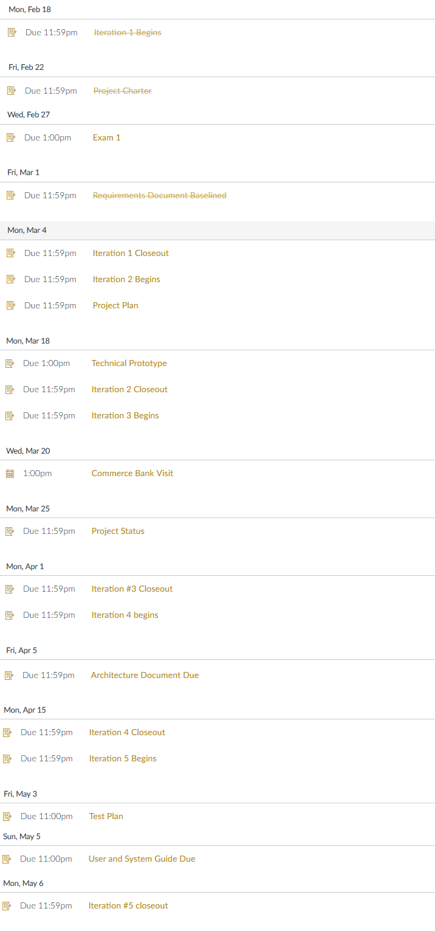

Success Criteria
- Total project cost does not exceed estimate.
- All project milestones must be completed on schedule.
- All project deliverables are developed to high standard.

Definitions
Use case – describes a goal-oriented interaction between the system and an actor. A use case may define several variants called scenarios that result in different paths through the use case and usually different outcomes.
User – the individual or individuals who will interact directly with the Save’n Score application
User Interface (UI) - the screen or screens, view or views that the user interacts with.
Scenario – one path through a use case
Actor – user or another software system that receives value from a use case.
Role – category of users that share similar characteristics.
Save’n Score (Product) – what is being described here; the software system specified in this document.
Project – activities that will lead to the production of the product described here. Project issues are described in a separate project plan.
Shall – adverb used to indicate importance; indicates the requirement is mandatory. “Must” and “will” are synonyms for “shall”.
Should – adverb used to indicate importance; indicates the requirement is desired but not mandatory.
May – adverb used to indicate an option. For example, “The system may be taken offline for up to one hour every evening for maintenance.” Not used to express a requirement, but rather to specifically allow an option.
Controls – the individual elements of a user interface such as buttons and checkboxes.
DB - Shorthand for the database.
Developer - the person or group of persons organizing, designing and implementing the application.
Stakeholder – those persons with a vested interest in the project’s performance. Note: view Project Charter for specific persons.

Evolution of the Project Plan
Before each iteration, the project plan will be updated to the link new iteration plan. Risk mitigation efforts will be evaluated by group.

Startup Plan

Team Organization
This section explains project roles and the authorities and responsibilities associated with these roles. Lines of communication, authority and reporting relationships are often shown with an org chart. If development team is known, actual names can be associated with roles.
Partial Example
Project Manager: The project manager is responsible for creating the project plan (with input from those doing the work), managing risks, running the weekly team meeting and providing monthly status reports to senior management.
Programmers (3): Programmers are primary responsible for coding and unit testing modules. They are also expected to take part in architecture planning and review meetings.
Build Coordinator: The build coordinator is responsible for setting up, running and distributing the results of the nightly build.

Project Communications
This section contains the project communications plan. The communications plan describes how information is gathered and distributed.

Technical Process
This section describes the software development methodology or conventions the team agrees to live by. When following an organization standard process, this section will refer to the standard process and state any deviations that are planned for this project. In the absence of an organization standard process, this section will define planned phases, entry and exit criteria for each phase, major milestones, workflows, and other aspects of the proposed development process.

Tools
This section specifies the development tools the team will be using to perform their work.

Partial Example
- Programming Language – Java
- Version Control – source code and written artifacts will be stored in a Subversion repository.
- Defect tracking – defects and issues will be tracked using Bugzilla.
- Build tools – local and main builds will be done using CodeMake.
- Automated testing – unit tests will be implemented with the JUnit testing framework.

Work Plan

Activities and Tasks
A work breakdown structure is an excellent tool for identifying a complete list of tasks.
Depending on the needs of the project, some or all of the following attributes will be recorded for each task:
- Task name
- Task Description
- Owner
- Effort estimate
- Actual effort
- Planned start and stop dates
- Actual start and stop dates
- Dependencies among other tasks

Release Plan
For day-to-day project management the release and iteration plans (described in the next section) are probably the two most important project management artifacts.
The release plan lists expected completion dates for major milestones and delivery dates of key work products. The project’s technical development process to a certain extent will dictate the choice and timing of milestones and deliverables. For example, projects following the Rational Unified Process will have four major milestones: life-cycle objectives, life-cycle architecture, initial operation capability, and product release.

Iteration Plans
An iteration plan is a short-term fine-grained plan that shows the tasks to be completed during an iteration.

Budget
The project budget is the projected cost of the project as a function of time. At any point in the project you should be able to say how much money has already been spent and estimate of the amount of money needed to complete the project.

Control Plan

Monitoring and Control
Include in this section plans and procedures for tracking progress and controlling performance. Included here will be the approximate dates of technical as well as managerial reviews. Typically each major milestone or project phase will end in a review.
For projects that don’t have a separate communication plan, this section may also include information on the timing and content of status reports and other project review documentation.
Partial Example
Weekly – Team meeting. Project participants report status, progress and potential problems.
3/1/2008 – Critical Design Review. Formal inspection of product architecture.
5/15/2008 – Executive Review. The project manager presents current project status to project sponsor and senior executives.

Project Measurements
Product and process measures support project management and estimation by analogy. At the beginning of a project, estimates are made for product size, project cost and delivery dates. During a project, progress is tracked with measures of actual effort, integrated lines of code and actual expenditures. Keeping track of estimates and actuals during a project helps to calibrate whatever technique is being used to make estimates. Storing project performance data on completed projects provides a rich source of data for estimating future projects.

Example
Phase | Measurement | Source
Release Planning | Record effort estimates for product features | Mgr
Iteration Planning | Record effort estimates for scheduled tasks  Update effort estimates for product features  Update estimated dates in release plan | Mgr
Iteration Closeout | Record actual effort for scheduled tasks  Record actual effort for product features  Record LOC count for modules written | Mgr/Pgr
System Test | Record the rate at which errors are found. | QA
Project Closeout | Archive project performance data in process database. (See process database definition for a list of measures to record.) | Mgr
Ongoing | Record defects found from integration testing through first year of release.  Assign each defect to one of the following categories: blocker, critical, major, minor or trivial. Keep track of the state of each defect: open, assigned, fixed, closed. | Mgr/Pgr/QA

Supporting Process Plans

Risk Management Plan
Identify technical and managerial risks. Prioritize risks. Consider the probability of each risk turning into a problem and the likely consequences. For the highest priority risks, what actions will be taken to minimize the probability of the risk turning into a problem and the resulting consequences? What are the contingency plans for selected risks that do become a problem? Identify processes for monitoring risks and updating the risk management plan.

Configuration Management Plan
Configuration management plans for this document and other baselined work products including review procedures and change management procedures.

Partial Example
- All work products will be stored in a centralized CVS repository running on a central server.
- The naming convention for documents will be: NNN-VVV.suffix where NNN is a mnemonic that reflects the function of the document, VVV is a 3 digit version number, and 'suffix' is the standard/normal suffix for the document type. For example, the second version of the requirements document created as a Microsoft Word document might be labeled: REQ-002.doc.
- All project (work products) items (documents, source code, test cases, program data, test data, etc) will be stored in the CVS repository but not all will be under change control (subject to formal change control procedures.) Only the system requirements, project plan and source code will be baselined and under configuration control.
- Items that are subject to change control will be considered baselined after a group review at the end of the life cycle phase during which they are created. Baselined here means that the product has undergone a formal review and can only be changed through the prescribed change control procedures.
- The change control procedure once a product is baselined is: (1) anyone wanting to make a change to a baselined item sends an email to the rest of the group describing the change, reason for the change, expected impact, and timeline for integrating the change. (2) if no one responds to the group within 2 days with a reason for why the change request shouldn't be permitted, it will be considered accepted and the person proposing the change may proceed with the change. If anyone does object to the change, the reason for objecting will be discussed at a meeting where everyone is invited to attend and voice their opinion. At the end of the meeting a democratic vote will be held to decide whether or not the change should be allowed.
- Including a change history with all documents is encouraged but only required for baselined documents. The change history should be at the front of the work item and include: (1) the name of the person making the change, (2) brief description of what has changed, (3) reason for the change, and (4) the date the change was integrated.

Verification and Validation Plan
The verification and validation plan defines what actions are being taken to assure the quality of the development process and resulting software products.

Partial Example
The Verification and Validation plan is specified as a separate documented located in the version control system at: http://company.com/svn/project-name/docs/VandVPlan.doc

Product Acceptance Plan
The product acceptance plan defines what is acceptable in terms of product quality and product functionality. Acceptance criteria should be objective and measurable. Note product success is one aspect of project success. Teams wanting to establish a clear understanding of what will be considered acceptable project performance may want to define a more general plan for project success that includes quantitative goals for delivery date, cost, etc.

Partial Example
The Verification and Valida

